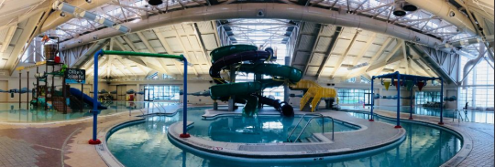Silliman Family Aquatics Center
Water Slide and Lazy River INSPECTOR Training - 2020
Staff Training Agenda
I. Hand out training materials to participants and review general elements of training program II. Communicate where manufacture manual is located for staff to review
III. Posted Rules for Water Slides & Activity Structure Slides and Splash Pool
IV. Dispatch Lifeguard Position/Top of the Slide Training for Water Slides
A. Handout of duties
B. Demonstration of duties from trainer
C. Simulated practice by trainee
V. Splash Pool Lifeguard Position/Bottom of the Slide Training
VI. Dispatch Lifeguard Position/Top of the Slide Training for Activity Structure Slides VII. Posted Rules for Lazy River
VIII. Lazy River Lifeguard Responsibilities
A. Handout of duties
B. Demonstration of duties from trainer
C. Simulated practice by trainee
IX. Emergency Evacuation Plans
A. Review handout
B. Run through drill
X. E-STOP Procedures
XI. Review of Inspection Criteria and Sheets
A. Physical walk through of slides and lazy river demonstrated with inspection
B. Shadow review of each candidate as they inspect slides and river
XII. Questions and clarification
XIII. Operator Training Documentation Forms
I. Hand Out Training Materials
II. Manufacturer Manual Location
A. Manuals are located on the newarkguard.com website for your review and reference.
B. Soft copies of the manuals can be found under the “Staff Forms - Aquatic Department Files” folder on the website.
III. Posted Rules for Water Slides and Splash Pool
Posted Rules for Water Slides
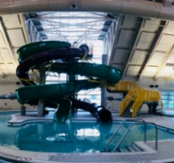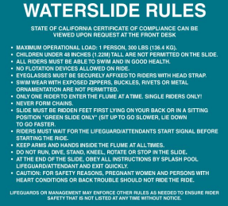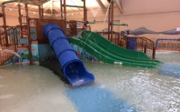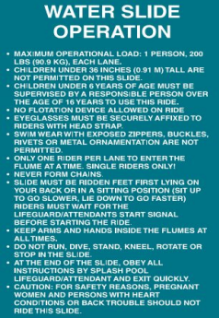
Posted Rules for Activity Pool Water Slides & Splash Pool
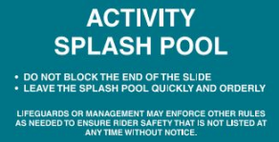
IV: Dispatch Lifeguard Position/Top of the Slide Training for Water Slides
General:
Dispatch Lifeguards should be alert to control crowd behavior, ensure safe and orderly entry and exit and control the proper entry rate into the slide. Additionally, the Dispatch Lifeguard is responsible for monitoring of slide line, position guest onto landing, going over slide script, dispatching when given the “okay” sign. The Dispatch Lifeguard is also responsible for evacuating the stairs in the event of an emergency, as well as activating the emergency action plan.
The area at the top of every water slide must be supervised by at least one attendant who has continuous and direct supervision of that area and is responsible for:
● Ensuring that customers conduct themselves in a safe and orderly manner.
● Ensuring that customers enter slides or rafts/mats properly.
● Ensuring that customers are dispatched at safe intervals.
● Visually surveying all areas of the water slide that are visible from attendant’s position, with the exception of the splash pool, and communicating any problems to the other attendants.
● Ensuring that customers meet the minimum and/or maximum restrictions for the slide.
Specific:
Line monitoring: To avoid being rushed by patrons you must keep guest behind yellow line on landing until you have dispatched riders. Once ready ask the next 2 guest to come onto the landing while insuring no other guest come forward.
Monitoring Height/Weight requirements: All riders must be at least 48 inches tall. If there is a question in a rider meeting this requirement check them with the height sign affixed to the railing. Insure height by placing guest against height requirement sign. All riders must be less than 300 lbs. An individual who is over 5’ tall and looks overweight by protruding belly etc. should be reminded of the weight requirement and If you have any concerns please ask the rider for their weight. If the rider indicates they are 300lbs+ or if they refuses to indicate you must send them down the stairs or sent to the Sr. Guard or Aquatic Coordinator to verity. Additionally, if you have any concerns that they may get lodged within the closed slide due to their size you are to send them down the open slide if you have deemed them to be within weight criteria.
Positioning Riders: Indicate the cautions to riders from script (attached). Have guest sit on launch platform with legs extended on the water slides behind the flow of water. Have riders hold onto the launch railing. Send riders when given the thumbs up by the Splash Entry Lifeguard.
Bringing in new riders: Once the previous riders have been dispatched bring up the next 2 riders from the line and follow the previous instructions.
Single rider: If only one rider is to go down this will be indicated by a thumbs up on the side where the rider will be going down.
Communicating Issues: If there are any issues signal to the splash entry lifeguard by whistling 2 short blasts and raising rescue tube. The splash entry guard will blow whistle 2 short times and get attention of Senior Guard who will stop water flow to slides and address the situation.
Stopping the ride: Either the dispatch or splash entry lifeguard can stop the ride for any reason.
For a general stop: The dispatch guard is to alert splash down guard by blowing whistle 2 short blast and alerting splash entry lifeguard who will do the same. The dispatch lifeguard will send all patrons behind yellow line at the stairs. When safe to do so they will give the thumbs up sign indicating they will be restarting.
For an emergency stop: The dispatch lifeguard will blow 1 long blast from air horn alerting all facility guards to activate the emergency action plan. All patrons will be evacuated and water will be stopped by Dispatch guard. Once this is done the dispatch lifeguard will escort guest down walkway and lock and secure gate before proceeding back up the slide to attend to the emergency. The ride will resume once emergency is resolved, ride is deemed safe, inspected and tested if necessary and both lifeguards are back on station and a thumbs up is given by both.
Dispatch Lifeguard Check for Each Rider:
● Height-over 48 inches
● Weight-under 300 pounds
● Check for exposed zippers, buckles, rivets, or metal objects
● Eyeglasses/goggles securely fastened
● One rider at a time per slide
● Rider in proper position
● Splash pool is clear
Dispatch Lifeguard Responsibilities for Each Rider:
1. Ask each rider if they know how to ride the ride by reading the dispatch script below.
2. Assure the rider is in the correct body position when ready.
3. Control dispatch of riders one at a time and shall not dispatch a rider until the flume is clear of obstruction and any previous rider.
4. Ensure all riders meet requirements.
a. Rider’s height is over 48 inches
b. Rider’s weight is under 300 pounds
5. Ensure eyeglasses are securely affixed to the riders.
6. Observe bathing suits for zippers, buckles, rivets, etc. and do not allow them on the slide. 7. Observe riders for any physical impairments that compromise safety and do not allow them on the slide. 8. Ensure the crowd behaves in a safe and orderly manner.
9. Monitor riders in areas visible from assigned positions.
Dispatch Script for Each Rider: The following Dispatch Script must be read to every rider behind the yellow line before entering the platform:
“All riders must follow all rules that have been posted for the slide. When riding you must be riding feet first lying on your back. Keep arms and hands crossed and inside the slide at all times. Do not dive, stand, kneel, rotate or stop in the slide. For safety reasons pregnant women, persons with heart conditions or back trouble should not ride the slide. You must know how to swim in order to go down the slide. Please exit to the stairs straight across the slide. Do you have any questions? Enjoy your ride.”
(Position riders and dispatch when given all clear from Splash Entry Lifeguard)
V. Splash Pool Lifeguard Position/Bottom of the Slide Training
General:
The Splash Pool Lifeguard indicates when it is safe to dispatch the next rider by communicating with the Dispatch Lifeguard stationed at the top of the slide. Additionally, they are responsible for watching the entry of riders and insure they exit splash down pool safely. Finally, they must watch that no one comes into the splash entry from the Lazy River.
The Splash Pool must be supervised by at least one certified lifeguard who has continuous and direct supervision of that area and is responsible for:
● Ensuring that customers conduct themselves in a safe and orderly manner.
● Ensuring that customers move into and out of splash pool in a quick and orderly manner. ● Controlling running, horseplay or other unsafe behavior on pool decks.
● Ensuring pool water levels are correct and as per marked water levels.
● Correct operating water level is critical to safe operation.
Specific:
Signaling to Dispatch Lifeguard: once a rider from the open slide enters the water the splash entry lifeguard will give a thumbs up sign indicating it is safe to dispatch the next rider. If it is not safe the splash entry guard will raise rescue tube horizontally over head indicating not to dispatch rider.
Entry of riders: splash entry will watch each entry and ensure guest is safely moving to exit stairs. If guest is struggling, the splash entry guard will blow one long whistle blast will tap had with hand indicating to lazy river guard to watch his station. Splash entry guard will enter the water and make an appropriate rescue on the guest and bring to safety and then escort guest to the first aid room to fill our a rescue report. The ride will not start again until another lifeguard is stationed at the splash entry pool.
Exit of riders: guest will exit from the stairs directly in line with the stairs. All guests are expected to exit and then go across the walkway or enter the lazy river from the landing.
Stopping the ride: Either the dispatch or splash entry lifeguard can stop the ride for any reason.
For a general stop: the splash entry guard is to alert the dispatch lifeguard by blowing whistle 2 short blast and holding rescue tube horizontal above head. The dispatch lifeguard will stop riders and put them behind yellow line until given the thumbs up signal from splash entry lifeguard.
For an emergency stop: the splash entry lifeguard will blow 1 long blast from whistle alerting all facility guards to activate the emergency action plan. All patrons will be evacuated and water will be stopped by Dispatch guard or Senior lifeguard. Once this is done the dispatch lifeguard will escort guest down walkway and lock and secure gate before proceeding back up the slide to attend to the emergency. The splash entry guard will attend to the emergency and call for backup as needed. The ride will resume once emergency is resolved ride
is deemed safe, inspected and tested if necessary and both lifeguards are back on station and a thumbs up is given by both.
Duties:
1. Ensure customers conduct themselves in a safe and orderly fashion.
2. Do not allow riders to block the end of a slide. Delay dispatch of next rider if the 3. slide landing area is obstructed.
4. Ensure that all riders exit the pool immediately upon splashdown. Do not permit 5. guests to sit on pool steps or congregate around pool edge.
6. Be prepared to enter splash pool to assist customer out of pool.
7. Do not allow any swimming or flotation devices in splash pool.
8. NOTE: Special attention is required at the splash pool due to reduced visibility from flowing water and the splash caused by riders entering the pool. The clarity of quiescent splash pool water is normally acceptable if no turbidity is noted and the bottom detail is clearly visible.
VI. Dispatch Lifeguard Position/Top of the Slide Training for Activity Structure Slides
General:
Dispatch Lifeguards ensure safe and orderly entry and exit and control the proper entry rate into the slide. Additionally, the Dispatch Lifeguard is responsible for monitoring of slide line, position guest onto landing, going over slide script, dispatching when given the area below is clear.
The area at the top of every water slide must be supervised by at least one attendant who has continuous and direct supervision of that area and is responsible for:
● Ensuring that customers conduct themselves in a safe and orderly manner.
● Ensuring that customers enter slides or rafts/mats properly.
● Ensuring that customers are dispatched at safe intervals.
● Visually surveying all areas of the water slide that are visible from attendant’s position, with the exception of the splash pool, and communicating any problems to the other attendants.
● Ensuring that customers meet the minimum and/or maximum restrictions for the slide.
Specific:
Monitoring Height/Weight requirements: All riders must be at least 36 inches tall. If there is a question in a rider meeting this requirement check them with the height sign affixed to the railing. Insure height by placing guest against height requirement sign. All riders must be less than 200 lbs. If you have any concerns please ask the rider for their weight. If the rider refuses you must send them down the stairs. Additionally, if you have any concerns that they may get lodged within the closed slide you are to send them down the open slide.
Positioning Riders: Indicate the cautions to riders from script (attached). Send riders when the area below is clear.
Bringing in new riders: Once the previous riders have been dispatched bring up the next 2 riders from the line and follow the previous instructions.
Communicating Issues: If there are any issues signal to the splash entry lifeguard by whistling 2 short blasts and raising rescue tube. The splash entry guard will blow whistle 2 short times and get attention of Senior Guard who will stop water flow to slides and address the situation.
Dispatch Lifeguard Check for Each Rider:
● Height-over 36 inches
● Weight-under 200 pounds
● Check for exposed zippers, buckles, rivets, or metal objects
● Eyeglasses/goggles securely fastened
● One rider at a time per slide
● Rider in proper position
● Splash pool is clear
Dispatch Lifeguard Responsibilities for Each Rider:
1. Assure the rider is in the correct body position when ready.
2. Control dispatch of riders one at a time and shall not dispatch a rider until the flume is clear of obstruction and any previous rider.
3. Ensure all riders meet requirements.
a. Rider’s height is over 36 inches
b. Rider’s weight is under 200 pounds
4. Ensure eyeglasses are securely affixed to the riders.
5. Observe bathing suits for zippers, buckles, rivets, etc. and do not allow them on the slide. 6. Observe riders for any physical impairments that compromise safety and do not allow them on the slide. 7. Ensure the crowd behaves in a safe and orderly manner.
8. Monitor riders in areas visible from assigned positions.
Dispatch Script for Each Rider: The following Dispatch Script must be read to every rider behind the yellow line before going down the slide:
“All riders must follow all rules that have been posted for the slide. When riding you must be riding feet first. Do not dive, stand, kneel, rotate or stop in the slide. For safety reasons pregnant women, persons with heart conditions or back trouble should not ride the slide. Please leave the splash pool quickly and orderly.”
VII. Posted Rules for Lazy River
1. All non-swimmers must be accompanied by an adult.
2. Any guest wearing a life jacket must be within arms reach of an adult.
3. All guests must go in the direction of the current
4. All guests must enter and exit at Lazy River stairs only.
VIII. Lazy River Lifeguard Responsibilities
General:
Observe patron use in the specific zone applied to, provide emergency rescue as indicated, and provide safe usage amongst guest.
Specific:
Entry: Lazy River Lifeguards make sure all guests enter area safely. Do not allow diving or jumping. Guest must do a feet first front entry in a safe manner, preferably easing in.
Exit: guest may exit at any point except interior in drop zone area. Ensure guest get out safely. If a guest is having problems direct them to exit at stairwell.
Stopping the lazy river: any guard on station may stop the river for any river to ensure safety. Lifeguard would blow whistle 2 long whistle blast and Senior Lifeguard or slide dispatch would stop river flow from e-stop. Pool would be cleared and then the emergency would be tended to. The lazy river would be restarted once all lifeguards are in place and give thumbs up to restart river. The senior lifeguard would start the motor to resume the river.
Area of coverage: depending upon the amount of guests utilizing the lazy river would indicate how many lifeguards are needed. There will always be a minimum of 3 with a maximum of 4. Coverage areas are in the lifeguard manual.
IX. Emergency Evacuation Plans
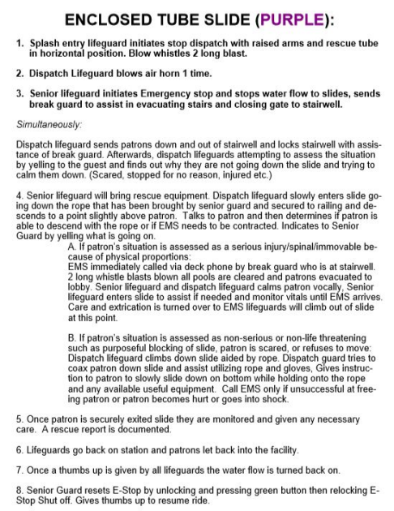
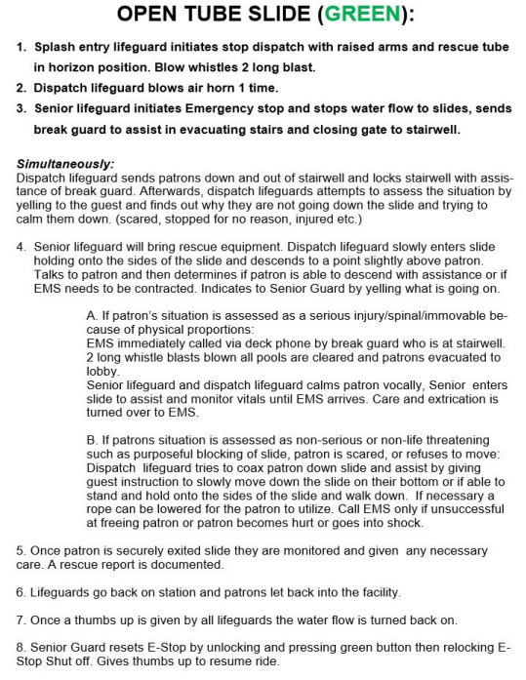
LAZY RIVER EMERGENCY EVACUATION PLAN:
1. Lifeguard initiates stop water flow with raised arms and rescue tube in horizontal position. 2. 2 long whistle blast indicates emergency and to stop river flow.
3. Lifeguards direct patrons to exit at the stairwell and assist in any rescue.
Simultaneously:
Senior lifeguard verifies the Emergency stop and stops water flow to slides, sends break guard to assist in evacuating from stairwell or Basic Life Support.
● Senior lifeguard and break lifeguard(s) bring rescue equipment.
● Initiating Lifeguard makes appropriate rescue with assistance of other guards.
● EMS immediately called via deck phone by break guard who is at stairwell.
● 2 long whistle blasts blown all pools are cleared and patrons evacuated to lobby. If patron’s situation is assessed as non-serious or non-life threatening then the situation is remedied.
1. Once patron has securely exited lazy river they are monitored and given any necessary care. A rescue report is documented on incident.
2. Lifeguards go back on station.
3. Once a thumb up is given by all lifeguards the water flow is turned back on.
4. Patrons let back into area
X. EMERGENCY STOP (E-STOP) PROCEDURES
1 Air Horn Blast signals to all staff on duty that E-stop will be activated.
AIR HORN LOCATIONS
Water Slide Dispatch – Remote E-Stop
WATER SLIDE DISPATCH
1. If you hear 1 air horn blast, activate e-stop by pressing the red button.
2. If you hear 2 long whistle blasts and see that it is a life-threatening emergency that would require the shutting down of the Activity Pool Play Structure, Lazy River, and/or the Water Slides, activate e-stop by initiating 1 air horn blast & then pressing the red button.
3. If there is an emergency on or in the slide, activate e-stop by initiating 1 air horn blast.
SENIOR LIFEGUARD
1. If you hear 2 long whistles blasts and determine that the e-stop is needed, activate e-stop by initiating 1 air horn blast.
GROUND E-STOP
To be used as back-up e-stop if needed.
POOL TECHNICIAN AND SENIOR LIFEGUARD
SLIDE AND RIVER INSPECTION TRAINING DOCUMENTATION
I __________________________________________ have been trained and have been demonstrated and have demonstrated back the proper operation, inspection, maintenance of the 2 water slides and lazy river at the Silliman Family Aquatic Center.
Additionally, as part of my training, I have watched the “Slide/River Inspection Video” found on the Newark Guard website. https://www.youtube.com/watch?v=pgK6NfgMWpo
I am fully aware of my duties, emergency shut off, safety, and emergency procedures as it relates to the blue slide, the purple slide and the lazy river. I am fully aware what is required prior to opening and during operations of these features and if for any reason feel the ride is unsafe that I will not allow it to open and will notify management to correct the situation. I have been made aware that I am responsible for the safety of the operation and opening and operations of these features. I realize any deviation to proper procedures and documentation will be considered willful negligence on my part and grounds for separation.
____________________________________________ ______________________ (Signature) (Date)
____________________________________________ ______________________ (Witnessed by) (Date)
City of Newark
Silliman Family Aquatic Center
Training Program for Operator Attendants of the Aquatube, Pool Sider, and Lazy River
It is the intent of this training program to meet all applicable California Code of Regulations as it relates to these elements.
Initial Training and Refresher Training: Any employee who is assigned to work as a lifeguard will receive a minimum of 3 hours initial training as documented below. After receiving initial training each employee will receive a minimum of 2 hours of refresher training on an annual basis but not to exceed 18 months. Refresher training will consist of the exact elements of initial training with the exception of item 6 and 7 so that consistency of reference will be maintained. Also, in this way new employees can be placed with existing employees for training ease.
Elements of Training: The elements of this training program consist of the following:
1. Complete review of Waterslide Operations & Maintenance Manuals with copies available for all trainees. Specific emphasis will be placed on general safety procedures which are highlighted in the manual. Only those areas which are specific for the attendant will be covered.
2. A Physical walk through and demonstration of each Attendant position and specific aspects of each area.
3. Complete review of facility specific rules as it relates to each of these elements. Physical Copy of these rules is given to each employee.
4. Complete review of the written emergency Action Plan for each of these elements 5. A physical walk through and demonstration and simulation of specific emergencies as outlined in the emergency action plan.
6. A shadow program in which each new attendant is paired with a seasoned attendant at each position to observe the seasoned attendant as they perform the necessary duties.
7. A shadow review program in which each new attendant will be paired with a seasoned attendant in which they will demonstrate the physical performance of the assigned regularly-scheduled duties. 8. Regular in-service training to practice specific lifeguarding and emergency skills. 9. The last component of the training program is a written acknowledgement verification form where the employee signs that they have been trained and is aware of the operational and maintenance responsibilities associated with each element. This form also contains a witness signature so as to verify the person actually verifying the training is the one signing the form.
City of Newark
Silliman Family Aquatic Center
Training Program for Pool Technicians and Sr. Guards of the Aquatube, Pool Sider, and Lazy River
It is the intent of this training program to meet all applicable California Code of Regulations as it relates to these elements.
Initial Training and Refresher Training: Any employee who is assigned to work as a Pool Technician or Sr. Guard will receive a minimum of 4 hours of initial training as documented below. After receiving initial training each employee will receive a minimum of 3 hours of refresher training on an annual basis but not to exceed 18 months. Refresher training will consist of the exact elements of initial training with the exception of the shadow program item 5 so that consistency of reference will be maintained. Also, in this way new employees can be placed with existing employees for training ease.
Elements of Training: The elements of this training program consist of the following:
1. Complete review of Waterslide Operations & Maintenance Manuals with copies available for all trainees. Specific emphasis will be placed on general safety procedures which are highlighted in the manual. Only those areas which are specific for the attendant will be covered.
2. A Physical walk through and demonstration of each inspection and specific aspects of each element. 3. Complete review of the written emergency Action Plan for each of these elements 4. A physical walk through and demonstration and simulation of specific emergencies as outlined in the emergency action plan as it relates to the Sr. Guard or pool technician.
5. A shadow program in which each new Sr. Guard/ pool technician is paired with a seasoned Sr. Guard/technician to observe them as they perform the necessary duties.
6. A shadow review program in which each Sr. Guard/new technician will be paired with a seasoned Sr. Guard/pool technician in which they will demonstrate the physical performance of the assigned regularly-scheduled duties.
7. The last component of the training program is a written acknowledgement verification form where the employee signs that they have been trained and is aware of the operational and maintenance responsibilities associated with each element. This form also contains a witness signature so as to verify the person actually verifying the training is the one signing the form.

